**DHS data female and male samples**

**Dependent variable-Dropouts**

I joined the female and male datasets with the variables id, household id, gender, age, region, school status and educational attainment. After reducing the sample to respondents between 12 and 6 years old and eliminating the cases of respondents aged 16, not attending school but that completed secondary the final sample size is 10,942.

Descriptive statistics of dependent variable school status 0= not attending school, 1 = attending school.

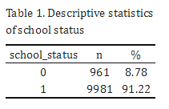

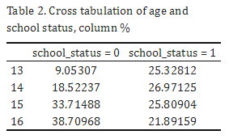

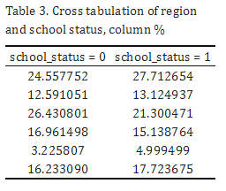

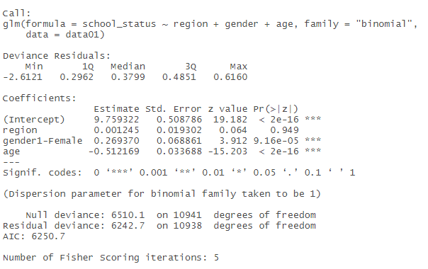

**Household dataset**

|  |  |
| --- | --- |
| **Original variable** | **Description** |
| Hhid  Case identification |  |
| Hv002  Household number |  |
| Hv009  Number of household members |  |
| Hv201  Source of drinking water |  |
| Hv206  Has electricity |  |
| Hv216  Number of rooms used for sleeping |  |
| Hv270a  Wealth index for urban/rural | 1.Poorest  2.Poorer  3.Middle  4.Richer  5.Richest |
| Sh63  Type of family |  |
| Sh68ab  Socioeconomic strata |  |
| Hv101_01:Hv101_21  Relationship to head | 1.Head  2.Wife or husband  3.Son/daughter  4.Son/daughter in law  5.Grandchild  6.Parent  7.Parent-in-law |
| Hv102_01:hv102_21  Usual resident | 0.No  1.Yes |
| Hv104_01:Hv104_21  Sex of household member |  |
| Hv105_01:Hv105_21  Age of household member |  |
| Hv106_01:Hv106_21  Highest educational level attained  FATHER | 0.No secondary  1.Primary  2.Secondary  3.Higher  8.Don´t know |
| HV108 Education in single years. |  |
| HV109 Educational attainment | Recodes the education of the household member into the following categories: None, incomplete primary, complete primary, incomplete secondary, complete secondary, higher education. |
| HV111 Whether the mother of the household member is still alive. | BASE: All children in the household aged less than 18. |
| HV112 Line number in the household of the mother of the member. | This variable is code 00 if the mother is not a member of the household. BASE: All children in the household aged less than 18. |
| HV113 Whether the father of the household member is still alive. | BASE: All children in the household aged less than 18. |
| HV114 Line number in the household of the father of the member. | This variable is code 00 if the father is not a member of the household. BASE: All children in the household aged less than 18. |
| Hc61  Mother´s highest educational level  Asked to children | 0 No education  1 Primary  2 Secondary  3 Higher  8 Don´t know  9 Missing |
| S117  Who did used to live with when between 12-14 years |  |
|  |  |

|  |  |
| --- | --- |
| **Original variable** | **Description** |
| Mv501  Current |  |
|  |  |
|  |  |
|  |  |
|  |  |
|  |  |
|  |  |
|  |  |
|  |  |
|  |  |
|  |  |
|  |  |
|  |  |
|  |  |
|  |  |
|  |  |
|  |  |
|  |  |
|  |  |
|  |  |